
CALL/WHATSAPP - 8970853557 / 9448005273
EXPRESSION TRANSFORMATION

Expression Transformation:
Create a mapping & add Expression Tx

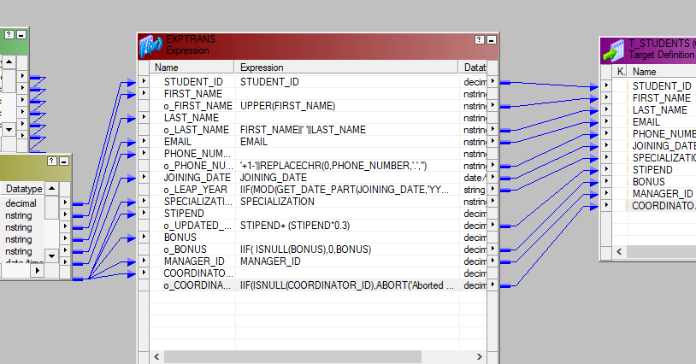
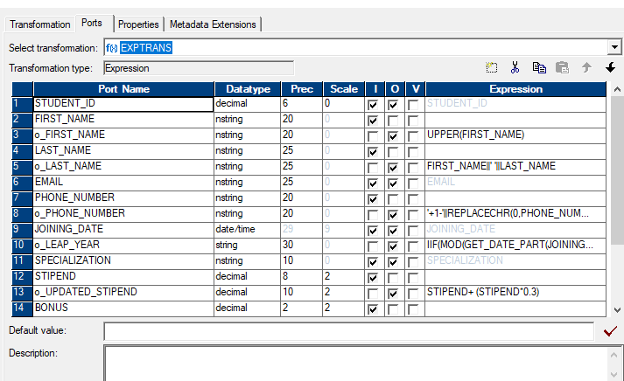
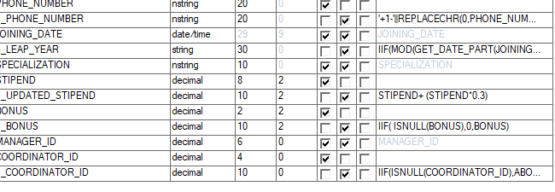
Different scenarios of Expression
o_First_name
UPPER(FIRST_NAME)
Making first_name with upper case (Give name as Updated first_name)
o_Last_name with concate
FIRST_NAME||' '||LAST_NAME
Making concate first_name and last_name
o_Email_id >>>
IIF(STIPEND>8000 ,EMAIL_ID||'@gmail.com',EMAIL_ID||'@yahoo.com')
If stipend > 8000 than make it as gmail_id else make it as yahoo.com
o_Phone_number >>>
'+1-'||REPLACECHR(0,PHONE_NUMBER,'.','') OR ANY ONE LOGIC
'+91 '||REPLACECHR(0,PHONE_NUMBER,'.','')
Concate '+91 'with phone number and remove dot(.) with null('')
o_Leap year
Add a column below Hire_date as o_Leap_year and connect this to Specialization
IIF(MOD(GET_DATE_PART(JOINING_DATE,'YYYY'),4)=0,'LEAP_YEAR','NONLEAP_YEAR')
STIPEND +STIPEND*0.15
IIF( ISNULL(BONUS),0,BONUS)
If comm pct is null than make it as 0 else make it as same as comm_pct
Abort the session if particular name is coming in the session

IIF(FIRST_NAME = 'Naresh',ABORT('Aborted due to received certain first_name'),FIRST_NAME)

Abort the session if any student is not allotted with coordinator_id
IIF(ISNULL(COORDINATOR_ID),ABORT('Aborted since student received without coordinator_id'),COORDINATOR_ID);
Exercises .1
____________

1. Take Students table as source
2. Consider the phone_number format in the source as below
944.800.5273
011.44.1345.829268
3. Load the phone number in the target as below
515.123.4567 > +91-94480-05273
011.44.1345.829268 > +91-01144-13458-29268
Solution
_______

IIF(length(PHONE_NUMBER)=12,'+91-'||substr(REPLACECHR(0,PHONE_NUMBER,'.',''),1,5)||'-
'||substr(REPLACECHR(0,PHONE_NUMBER,'.',''),6,5),'+91-
'||substr(REPLACECHR(0,PHONE_NUMBER,'.',''),1,5)||'-
'||substr(REPLACECHR(0,PHONE_NUMBER,'.',''),6,5)||'-
'||substr(REPLACECHR(0,PHONE_NUMBER,'.',''),11,5))

